Avontece Cabrera

SWDV 665

4/24/21

**Questions and Screen Shots**

https://github.com/SWDV-665/week-7-groceries-app-on-heroku-ACabrera-Codes.git

https://github.com/ACabrera-Codes/groceries.git

1. How many hours do you estimate you used completing this assignment? 3
2. What was easiest for you when completing this assignment? Taking screen shots.
3. What was the most difficult challenge you experienced when completing this assignment? Unable to use mlabs or the option one that was given as a solution. From the addons portion of the tutorial onward nothing worked. I tried to follow <https://docs.mlab.com/shutdown-of-heroku-add-on/> as suggested but that didn’t work because you cant migrate an mLab database directly to MongoDB Atlas since mlab already shut down…. I tried to search for other tutorials on connecting to atlas but nothing I found helped me. I was unable to deploy, below are the errors and what I have since there was not a deploy tutorial from this class nor could I find anything online to help. I created the app, and deployed via git bash, but I get an error and its not correct.

Created app:

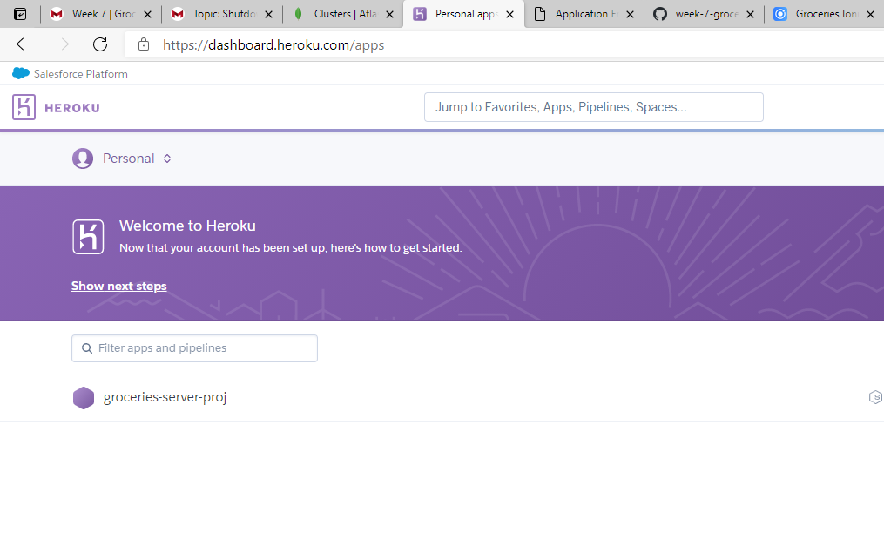

Deployed:

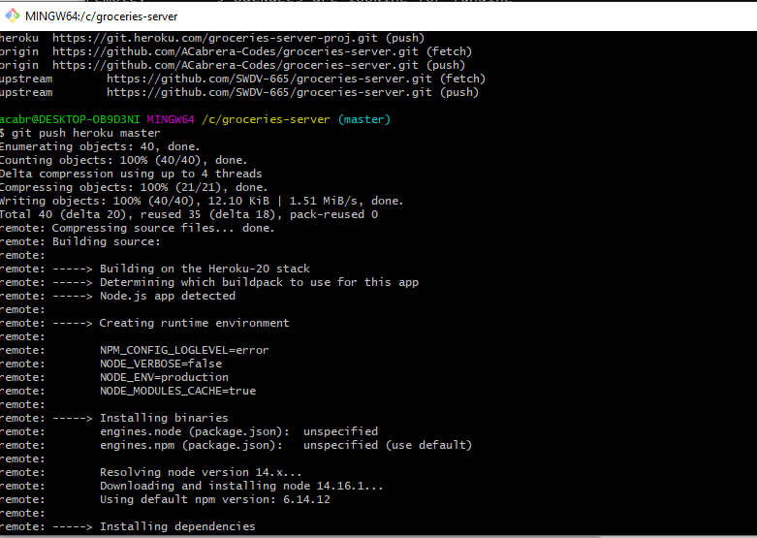

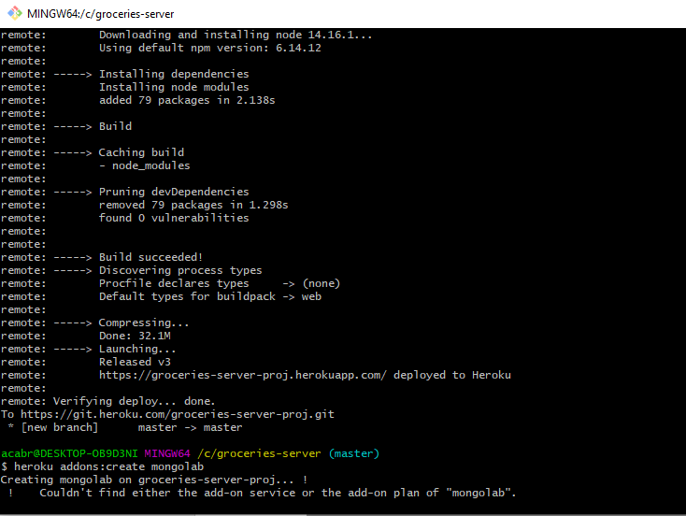

Application error :

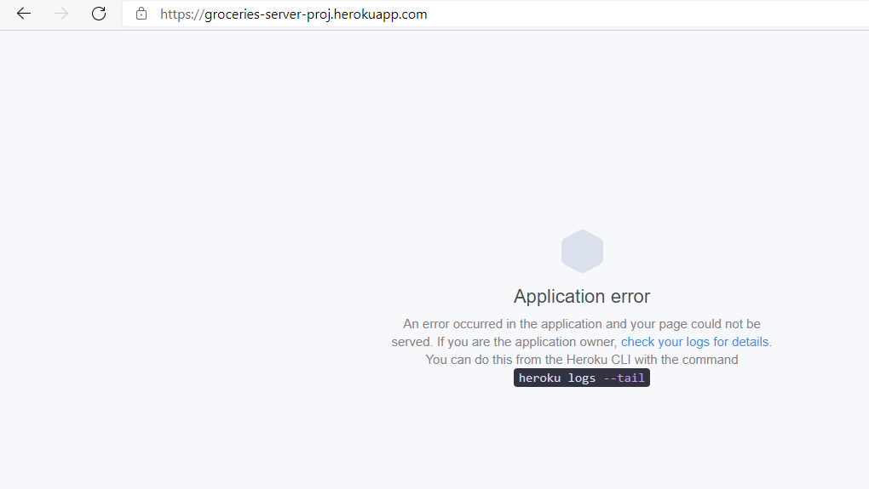

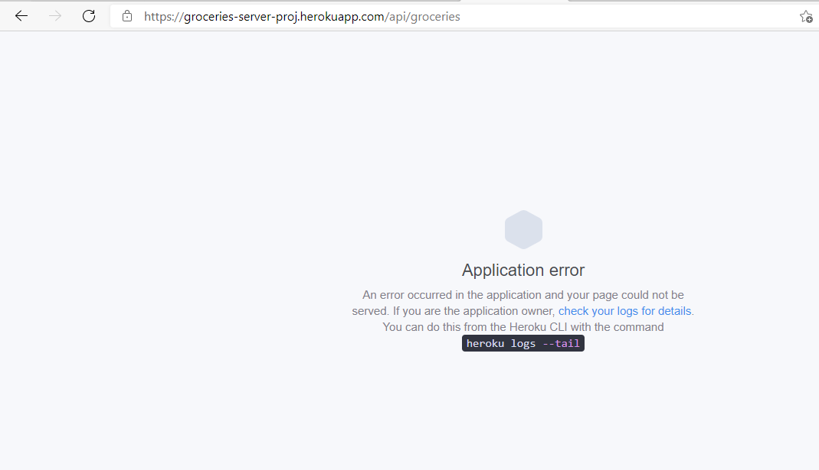

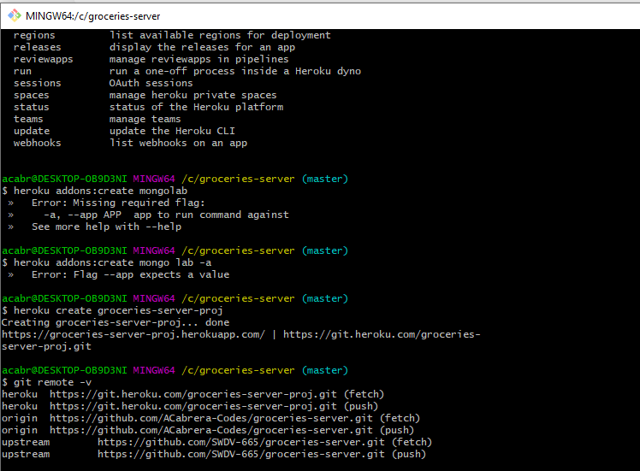

Logs:

acabr@DESKTOP-OB9D3NI MINGW64 /c/groceries-server (master)

$ heroku logs

2021-04-25T03:01:24.031418+00:00 app[api]: Release v1 created by user avontece@gmail.com

2021-04-25T03:01:24.031418+00:00 app[api]: Initial release by user avontece@gmail.com

2021-04-25T03:01:24.557239+00:00 app[api]: Release v2 created by user avontece@gmail.com

2021-04-25T03:01:24.557239+00:00 app[api]: Enable Logplex by user avontece@gmail.com

2021-04-25T03:04:06.000000+00:00 app[api]: Build started by user avontece@gmail.com

2021-04-25T03:04:23.427488+00:00 app[api]: Deploy ea035d17 by user avontece@gmail.com

2021-04-25T03:04:23.427488+00:00 app[api]: Release v3 created by user avontece@gmail.com

2021-04-25T03:04:23.448140+00:00 app[api]: Scaled to web@1:Free by user avontece@gmail.com

2021-04-25T03:04:24.000000+00:00 app[api]: Build succeeded

2021-04-25T03:04:27.345446+00:00 heroku[web.1]: Starting process with command `npm start`

2021-04-25T03:04:32.093380+00:00 app[web.1]:

2021-04-25T03:04:32.093401+00:00 app[web.1]: > groceries-server@0.0.1 start /app

2021-04-25T03:04:32.093402+00:00 app[web.1]: > node server.js

2021-04-25T03:04:32.093402+00:00 app[web.1]:

2021-04-25T03:04:32.356904+00:00 app[web.1]: internal/modules/cjs/loader.js:883

2021-04-25T03:04:32.356917+00:00 app[web.1]: throw err;

2021-04-25T03:04:32.356917+00:00 app[web.1]: ^

2021-04-25T03:04:32.356918+00:00 app[web.1]:

2021-04-25T03:04:32.356918+00:00 app[web.1]: Error: Cannot find module 'express'

2021-04-25T03:04:32.356918+00:00 app[web.1]: Require stack:

2021-04-25T03:04:32.356919+00:00 app[web.1]: - /app/server.js

2021-04-25T03:04:32.356927+00:00 app[web.1]: at Function.Module._resolveFilename (internal/modules/cjs/loader.js:880:15)

2021-04-25T03:04:32.356927+00:00 app[web.1]: at Function.Module._load (internal/modules/cjs/loader.js:725:27)

2021-04-25T03:04:32.356928+00:00 app[web.1]: at Module.require (internal/modules/cjs/loader.js:952:19)

2021-04-25T03:04:32.356928+00:00 app[web.1]: at require (internal/modules/cjs/helpers.js:88:18)

2021-04-25T03:04:32.356928+00:00 app[web.1]: at Object.<anonymous> (/app/server.js:2:15)

2021-04-25T03:04:32.356929+00:00 app[web.1]: at Module._compile (internal/modules/cjs/loader.js:1063:30)

2021-04-25T03:04:32.356929+00:00 app[web.1]: at Object.Module._extensions..js (internal/modules/cjs/loader.js:1092:10)

2021-04-25T03:04:32.356929+00:00 app[web.1]: at Module.load (internal/modules/cjs/loader.js:928:32)

2021-04-25T03:04:32.356929+00:00 app[web.1]: at Function.Module._load (internal/modules/cjs/loader.js:769:14)

2021-04-25T03:04:32.356930+00:00 app[web.1]: at Function.executeUserEntryPoint [as runMain] (internal/modules/run_main.js:72:12) {

2021-04-25T03:04:32.356930+00:00 app[web.1]: code: 'MODULE_NOT_FOUND',

2021-04-25T03:04:32.356930+00:00 app[web.1]: requireStack: [ '/app/server.js' ]

2021-04-25T03:04:32.356931+00:00 app[web.1]: }

2021-04-25T03:04:32.380747+00:00 app[web.1]: npm ERR! code ELIFECYCLE

2021-04-25T03:04:32.381318+00:00 app[web.1]: npm ERR! errno 1

2021-04-25T03:04:32.404260+00:00 app[web.1]: npm ERR! groceries-server@0.0.1 start: `node server.js`

2021-04-25T03:04:32.404262+00:00 app[web.1]: npm ERR! Exit status 1

2021-04-25T03:04:32.404264+00:00 app[web.1]: npm ERR!

2021-04-25T03:04:32.404264+00:00 app[web.1]: npm ERR! Failed at the groceries-server@0.0.1 start script.

2021-04-25T03:04:32.404266+00:00 app[web.1]: npm ERR! This is probably not a problem with npm. There is likely additional logging output above.

2021-04-25T03:04:32.440291+00:00 app[web.1]:

2021-04-25T03:04:32.440293+00:00 app[web.1]: npm ERR! A complete log of this run can be found in:

2021-04-25T03:04:32.440294+00:00 app[web.1]: npm ERR! /app/.npm/_logs/2021-04-25T03_04_32_409Z-debug.log

2021-04-25T03:04:32.534776+00:00 heroku[web.1]: Process exited with status 1

2021-04-25T03:04:32.649902+00:00 heroku[web.1]: State changed from starting to crashed

2021-04-25T03:04:32.653787+00:00 heroku[web.1]: State changed from crashed to starting

2021-04-25T03:04:34.882177+00:00 heroku[web.1]: Starting process with command `npm start`

2021-04-25T03:04:37.408002+00:00 app[web.1]:

2021-04-25T03:04:37.408022+00:00 app[web.1]: > groceries-server@0.0.1 start /app

2021-04-25T03:04:37.408023+00:00 app[web.1]: > node server.js

2021-04-25T03:04:37.408023+00:00 app[web.1]:

2021-04-25T03:04:37.479076+00:00 app[web.1]: internal/modules/cjs/loader.js:883

2021-04-25T03:04:37.479077+00:00 app[web.1]: throw err;

2021-04-25T03:04:37.479079+00:00 app[web.1]: ^

2021-04-25T03:04:37.479079+00:00 app[web.1]:

2021-04-25T03:04:37.479079+00:00 app[web.1]: Error: Cannot find module 'express'

2021-04-25T03:04:37.479079+00:00 app[web.1]: Require stack:

2021-04-25T03:04:37.479080+00:00 app[web.1]: - /app/server.js

2021-04-25T03:04:37.479080+00:00 app[web.1]: at Function.Module._resolveFilename (internal/modules/cjs/loader.js:880:15)

2021-04-25T03:04:37.479081+00:00 app[web.1]: at Function.Module._load (internal/modules/cjs/loader.js:725:27)

2021-04-25T03:04:37.479081+00:00 app[web.1]: at Module.require (internal/modules/cjs/loader.js:952:19)

2021-04-25T03:04:37.479081+00:00 app[web.1]: at require (internal/modules/cjs/helpers.js:88:18)

2021-04-25T03:04:37.479081+00:00 app[web.1]: at Object.<anonymous> (/app/server.js:2:15)

2021-04-25T03:04:37.479082+00:00 app[web.1]: at Module._compile (internal/modules/cjs/loader.js:1063:30)

2021-04-25T03:04:37.479082+00:00 app[web.1]: at Object.Module._extensions..js (internal/modules/cjs/loader.js:1092:10)

2021-04-25T03:04:37.479082+00:00 app[web.1]: at Module.load (internal/modules/cjs/loader.js:928:32)

2021-04-25T03:04:37.479083+00:00 app[web.1]: at Function.Module._load (internal/modules/cjs/loader.js:769:14)

2021-04-25T03:04:37.479083+00:00 app[web.1]: at Function.executeUserEntryPoint [as runMain] (internal/modules/run_main.js:72:12) {

2021-04-25T03:04:37.479083+00:00 app[web.1]: code: 'MODULE_NOT_FOUND',

2021-04-25T03:04:37.479083+00:00 app[web.1]: requireStack: [ '/app/server.js' ]

2021-04-25T03:04:37.479084+00:00 app[web.1]: }

2021-04-25T03:04:37.490728+00:00 app[web.1]: npm ERR! code ELIFECYCLE

2021-04-25T03:04:37.491016+00:00 app[web.1]: npm ERR! errno 1

2021-04-25T03:04:37.496791+00:00 app[web.1]: npm ERR! groceries-server@0.0.1 start: `node server.js`

2021-04-25T03:04:37.496901+00:00 app[web.1]: npm ERR! Exit status 1

2021-04-25T03:04:37.496994+00:00 app[web.1]: npm ERR!

2021-04-25T03:04:37.497045+00:00 app[web.1]: npm ERR! Failed at the groceries-server@0.0.1 start script.

2021-04-25T03:04:37.497097+00:00 app[web.1]: npm ERR! This is probably not a problem with npm. There is likely additional logging output above.

2021-04-25T03:04:37.504449+00:00 app[web.1]:

2021-04-25T03:04:37.504588+00:00 app[web.1]: npm ERR! A complete log of this run can be found in:

2021-04-25T03:04:37.504673+00:00 app[web.1]: npm ERR! /app/.npm/_logs/2021-04-25T03_04_37_497Z-debug.log

2021-04-25T03:04:37.552229+00:00 heroku[web.1]: Process exited with status 1

2021-04-25T03:04:37.606891+00:00 heroku[web.1]: State changed from starting to crashed

2021-04-25T03:09:18.715032+00:00 heroku[router]: at=error code=H10 desc="App crashed" method=GET path="/" host=groceries-server-proj.herokuapp.com request_id=e06a2fc9-63ac-4c9a-a3e2-d787c42288ad fwd="73.30.78.7" dyno= connect= service= status=503 bytes= protocol=https

2021-04-25T03:09:19.264855+00:00 heroku[router]: at=error code=H10 desc="App crashed" method=GET path="/favicon.ico" host=groceries-server-proj.herokuapp.com request_id=4f70a4fb-b038-40ec-bc47-8120650d3861 fwd="73.30.78.7" dyno= connect= service= status=503 bytes= protocol=https

2021-04-25T03:09:33.294790+00:00 heroku[router]: at=error code=H10 desc="App crashed" method=GET path="/api/groceries" host=groceries-server-proj.herokuapp.com request_id=fa6cc0fa-a3a7-40bb-83f9-f4021193e9d2 fwd="73.30.78.7" dyno= connect= service= status=503 bytes= protocol=https

2021-04-25T03:09:33.834933+00:00 heroku[router]: at=error code=H10 desc="App crashed" method=GET path="/favicon.ico" host=groceries-server-proj.herokuapp.com request_id=ebca126a-4020-4b81-8ac7-d7647bac193e fwd="73.30.78.7" dyno= connect= service= status=503 bytes= protocol=https